**STUDENT ENTRY**

*Submitted By*

**Vaishnavi Shantaram Dangat**

**VAD2017B.techCSE4F046**

*Guided By*

**Barkha wadhvani**

Assistant Professor, Computer Science and Engineering Department

ITM Vocational University, Vadodara

A Project Submitted to

Computer Science and Engineering Department

November- 2018



**ITM Vocational University, Vadodara**

**CERTIFICATE**

This is to certify that Project Report entitled “**STUDENT ENTRY**” was carried out by **Vaishnavi Shantaram Dangat** ( **VAD2017B.techCSE4F046**) at ITM Vocational University, Vadodara as fulfillment of IIIrd Semester subject. This study has been carried out under my supervision and is to my satisfaction.

Date:

Place:

Barkha Wadhvani

Assistant Professor,

CSE Department,

ITMVU,Vadodara

**ACKNOWLEDGEMENT**

I would like to express my special thanks to all those who spent their valuable time for guiding and helping me to complete the dissertation phase I successfully.

I express my gratitude towards my guide **Barkha wadhavani**, ITM Vocational University Vadodara for cordial and gentle nature.

I also appreciate my colleagues and friends for their constant inspiration and help.

**Vaishnavi Shantaram Dangat**

**VAD2017B.techCSE4F046**

|  |  |  |  |  |
| --- | --- | --- | --- | --- |
|  | **TABLE OF CONTENTS** | |  | |
| TITLE PAGE | | | i | |
| CERTIFICATE | | | ii | |
| ACKNOWLEDGEMENT | | | iii | |
| TABLE OF CONTENTS | | | iv | |
| LIST OF FIGURES | | | v | |
| ABSTRACT | | | vi | |
|  | | |  | |
| **CHAPTER- 1 : INTRODUCTION** | | |  | |
| 1.1 | Overview | |  | |
| 1.2 | Objective | | page No | |
| 1.3 | Motivation | |  | |
| **CHAPTER- 2 : TECHNOLOGY**  2.1 Technologies Name (e.g. javascript, CSS,HTML,Android)  2.2 Database Description (sql)  **CHAPTER- 3 : IMPLEMENTATION** | | |  | |
| 3.1 Flow chart  3.2 Results (e.g. Project Screenshots with explaination) | | |  | |
|  |  | |  | |
| **Conclusion** | | Page No | |
| **References** | |  | |
|  | |  | |
|  | |  | |
|  | |  | |

**LIST OF FIGURES**

|  |  |  |  |  |  |  |  |  |  |  |  |  |  |  |  |  |  |  |  |  |  |  |  |  |  |  |  |  |  |  |  |  |  |  |  |  |  |  |  |  |  |  |  |
| --- | --- | --- | --- | --- | --- | --- | --- | --- | --- | --- | --- | --- | --- | --- | --- | --- | --- | --- | --- | --- | --- | --- | --- | --- | --- | --- | --- | --- | --- | --- | --- | --- | --- | --- | --- | --- | --- | --- | --- | --- | --- | --- | --- |
| |  |  | | --- | --- | |  | 2 | |  |  | |  |  | | 1. Home page 2. Form page 3. Submission page 4. Record page |  | |  |  | |  |  | |  |  | |  |  | |  |  | |  |  | |  |  | |  |  | |  |  | |  |  | |  |  | |  |  | |  |  | |  |  | |  |  | |  |  | |  |  | |  |
|  |  |
|  |  |
|  |  |
|  |  |
|  |  |
|  |  |
|  |  |
|  |  |

**STUDENT ENTRY**

**Submitted By**

**Vaishnavi Shantaram Dangat**

**Supervised By**

Barkha Wadhvani

Assistant Professor, CSE Department

**ABSTRACT**

The main purpose of my project to solve hostel student problem to going outside and inside the hostel. In this project student can fill up their details in form. Like name, where they are going, and what reason they want to go , stream of the student date , in-time and out-time, mobile no.

The project is made up of three main languages HTML,CSS, and PHP . HTML use for form making the form. and CSS use for Designing the form. PHP plays main role in my project .They connect the data to connection means data connection, table formation etc. MYSQL language also use in this project to store a data in php myadmin*.*

**CHAPTER-1**

**Introduction**

* 1. **Overview**

In hostel student face some problem to going outside and inside hostel.

For the student i am made this website. The project name is student entry. In this project i am made form in that form you can enter your details like name ,where you go, for what reason your going outside, stream of student, in-time and out-time, mobile- no. etc This website help the student to going outside and inside the hostel.

**1.2Objective**

. Saves a student time.

. Easy to access of saved student details in database.

. Details can save in database and and there will be no change in details.

. It has easy to use.

**1.3Motivation**

I am also a hostel student and i face this problem in many days, In that reason i can decided this . And i make it. This is very useful and time saving.

**Chapter -2**

**TECHNOLOGY**

**2.1 Technologies name**

1. **HTML :** HTML is a fundamental coding language that creates and organize web

Content so it can be displayed by a browser. This language is used in

my website for making student form.

1. **CSS :** CSS is language that accompanies HTML, and defines the style of a

website’s content such as layout, colors, font etc. This language i used

for design my website.

1. **PHP :** PHP language used in this for the database connection, database table, and

some queries.

**2.2Database**

In this project MYSQL language used.

**Chapter-3**

**IMPLEMENTATION**

**3.1 FLOW CHART**

OPEN STUDENT ENTRY FORM THROUGH WEBSITE.

## 

FORM SUBMITTED SUCESSFULLY

SUBMITE THE FORM

FILL UP ALL DETAIL S IN HOME PAGE

* 1. **RESULT**

**1.REGISTRATION FORM:**

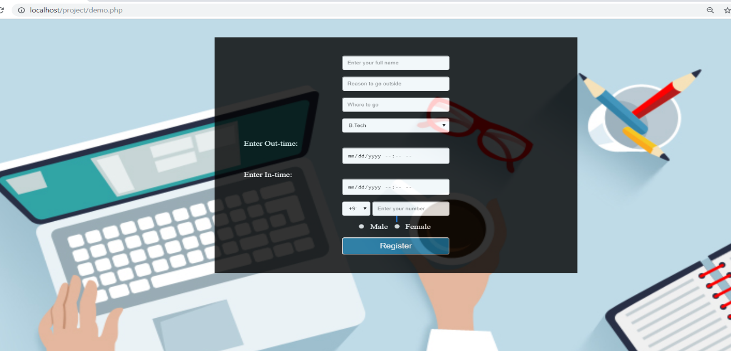

Fig 1. Registration form.

**2.DATABASE:**

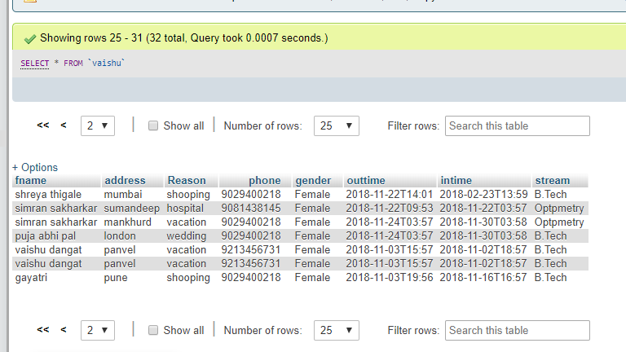

Fig 2. Database.

Conclusion

The website has successfully achieved its aims and objectives .The student entry form can effectively done by the system as discussed in the report.

Reference

1. <http://www.w3schools.com>

2. <http://youtube.com>